Energetics of Walking and Running
J. C. Sprott

Introduction

What follows is an estimate of the power consumed in walking and in running as a function of a person's mass (m), leg length (L), and running speed (v). The speed at which running becomes more efficient than walking is calculated. An estimate is given for the maximum sustained running speed. The minimum required coefficient of friction is calculated for walking and running.

Walking Model

Make the following assumptions about the walking process:

1) Each leg is stiff during the time of its contact with the ground like the spokes of a wheel, which thereby rotates without benefit of a rim, and thus each foot leaves contact with the ground at the instant the other touches the ground. The flexing of the knee of the free leg serves only to keep that foot from contacting the ground as its leg swings forward, and such flexure doesn't consume significant energy or change the natural period of oscillation of the leg.

2) The legs swing with their natural period, assumed to be given by T = 2π [2L / 3g]^{1/2}, where g = 9.8 m/s² is the acceleration due to gravity, independent of walking speed.

3) Energy is consumed in raising the center of mass of the body once per step, and this energy is not recovered when the center of mass is lowered again.

Under these assumptions, it is straightforward to calculate the power (energy per unit time) expended in walking:

P_{w} = (mg / π) [3gL / 2]^{1/2}{1 - [1 - π²v² / 6gL]^{1/2}}

Running Model

Make the following assumptions about the running process:

1) Each foot contacts the ground for a negligible time during which an impulsive force propels the body along a parabolic trajectory until the opposite foot strikes the ground.

2) The upward component of the velocity of the center of mass of the body at the instant the foot leaves the ground is equal to the horizontal velocity of the center of mass so as to achieve maximum range before the opposite foot strikes the ground.

3) Energy is consumed in raising the center of mass of the body once per step, and this energy is not recovered when the center of mass is lowered again.

Under these assumptions, it is straightforward to calculate the power (energy per unit time) expended in running:

P_{r} = mgv / 4

Numerical Example

As a specific example, and to see if the models are reasonable, calculate the power consumed for walking and running as a function of speed v for an individual with m = 100 kg and L = 1 m. The results are shown in Fig. 1. The powers increase with speed--linearly for running, and quadratically for walking at low speed. The powers consumed in walking and running are similar at a speed of about 2 m/s (about 4.5 miles per hour), and are about 500 Watts for our 100 kg (220 pound) person. These values seem reasonable.
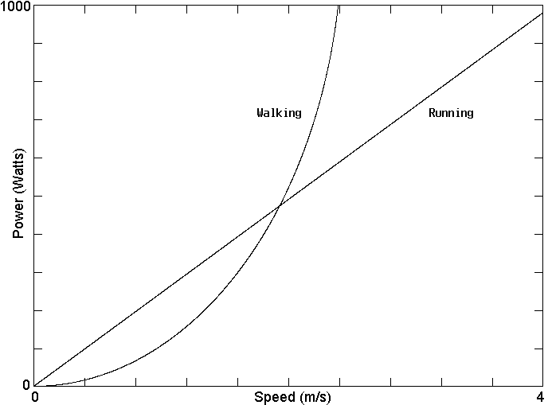
Figure 1. The power required to walk and to run at various speeds. Note that below a speed of about 2 m/s, it is more efficient to walk than to run, but above that speed, it is more efficient to run.

Transition Speed

It is easy to calculate the speed v_{c} above which running consumes less power than walking at the same speed. This is done by equating P_{w} to P_{r} and solving for v. The result is

v_{c} = (12 / 5π) [2gL / 3]^{1/2}

This critical speed depends only on the length of the leg, and the dependence is weak (square root). The prediction is that a shorter person will begin running at a lower speed than will a tall person, as expected. At the critical speed, the person advances forward by 8L / 5 with each step, which seems a bit large.

Note that on the moon where g is about one sixth of its value on the earth, the transition speed is about 2.5 times lower, and thus astronauts would be expected to run even when moving rather slowly, as seems to be the case. The result is independent of the mass of the person, and thus the bulky equipment carried by the astronauts should not alter the results. This prediction could be tested on a treadmill by having the subject carry a heavy backpack.

Maximum Running Speed

As the running speed increases, the legs have to oscillate more rapidly. It is extremely difficult to force them to oscillate faster than their natural resonant frequency. Additional energy, so far neglected, has to be expended to do so. If we take this resonant frequency as the upper limit of comfortable running, the maximum running speed vm can be calculated:

v_{m} = π[gL / 6]^{1/2}

The prediction is that tall people can run faster than short people, and that a person with legs 1 m long should have a maximum speed of 4.02 m/s (or 8.98 miles per hour). Sprinters can do somewhat better than this speed, but it is a reasonable upper limit for a marathon runner.

Friction Requirements

Experience suggests that it is harder to run on ice than to walk on ice. We can quantify this expectation by calculating the minimum coefficient of friction μ for which the foot does not slip for each case. For the walking case, the result is

μ = v / [6gL / π² - v²]

For the running case, the force is impulsive (it occurs over a very short time interval), and it is thus much larger than the person's weight. Furthermore, to launch the person at a 45° angle requires equal vertical and horizontal forces. Running thus requires μ = 1 independent of speed.

The minimum coefficients of friction required for walking and running are shown in Fig. 2. As expected, the minimum required coefficient of friction occurs for slow walking. However, above a speed of v = [3gL]^{1/2} / π = 0.884 v_{c}, it should be easier to run on ice than to walk.
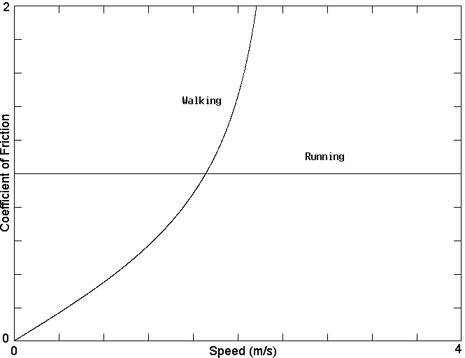
Figure 2. The minimum coefficient of friction required to walk and to run. Note that below a speed of about 2 m/s, it is easier to walk on a slippery surface than to run, but that above that speed it is easier to run, although the minimum coefficient of friction is 1.

