RSCDS John Muir Branch (Wisconsin, USA)
Number of years established as a branch: 4
Annual Report (May 2006-May 2007)
Respectfully Submitted by Kate Deck, Secretary

Members of the John Muir Branch of the RSCDS participated in many activities in conjunction with the Madison Scottish Country Dancers over the past year, including demonstrations, dance parties, our annual ball, and teacher training. Our September-2006 demonstration at the Dane County Farmers’ Market on Madison's Capitol Square attracted a jovial group of audience participants. We performed onstage September 30, 2006 at the World Dance Celebration, put on by the University of Wisconsin dance department. We have had several social dance evenings throughout the year, in addition to our regular Sunday evening dance classes. An afternoon dance party was held in December of 2006, featuring live fiddle and piano music by David Mullen and Mike Briggs. The annual ball was held April 7 at the University of Wisconsin Memorial Union and featured our favorite dance band O’er the Border. Carol Hassemer chaired the ball committee. We have undertaken a teacher training initiative to help some of our area dancers obtain their teaching certificates. Norma Briggs is offering a special technique class. Plans are underway to host a series of intensive teacher-training classes with tutors from the Teachers' Association of Canada.

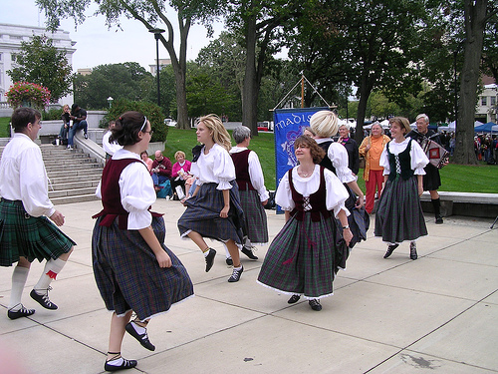
Farmers’ Market, Madison, USA, September 2006

