The NASA, Shuttle-Launch, Dark-Moon-Ray Mystery

Robert Greenler
Physics Department
University of Wisconsin-Milwaukee
Milwaukee, WI 53201

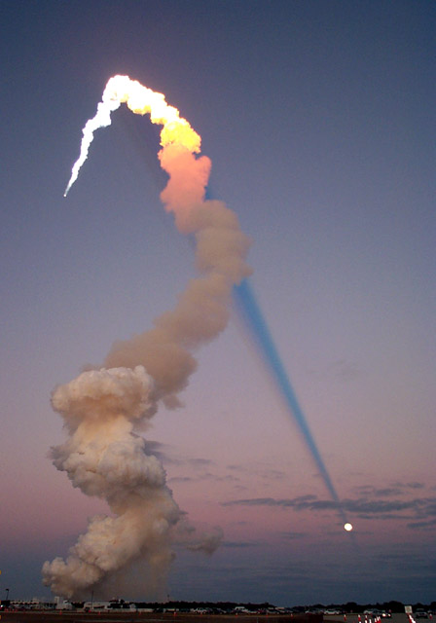

A photograph of the February 7,
2001 launch of the space shuttle Atlantis, shows many interesting sky effects. The most striking feature is the dark ray converging toward (or radiating from) the full moon.

The photo presents an interesting puzzle that can be understood, mostly without any additional information. A variety of effects visible in the photo will be discussed with the aid of slides, demonstrations, and a video segment.

